Acceptance Conformity for Radar5 VS412+Dispatch

Applicable for Radar 05 Product

RESTRICTED ACCESS

DISTRIBUTION :
Firm Recipient Copies
CFM James Nie 1
CFM Cecilia Xia 1
CFM Daniel Wang 1
CFM Steven Wu 1

REVISION

Revision Date Author Comments

A 2022-11-29 James Nie Initial Release

CONTENTS

1. REFERENCE 4
2. OBjective 4
3. Method of measurement 6
4. List of the ACCEPTANCE CRITERIA for eOL STATION 6
5. Conclusion 6

REFERENCE

Trial date : 2022/11/29

Trial done by :James Nie

Line : Radar 5

Equipment: EPE-0104-07-01

OBjective
Verify the conformity of the Radar-5 VS412+Dispatch table with the production requirements and validate it can be used for production.
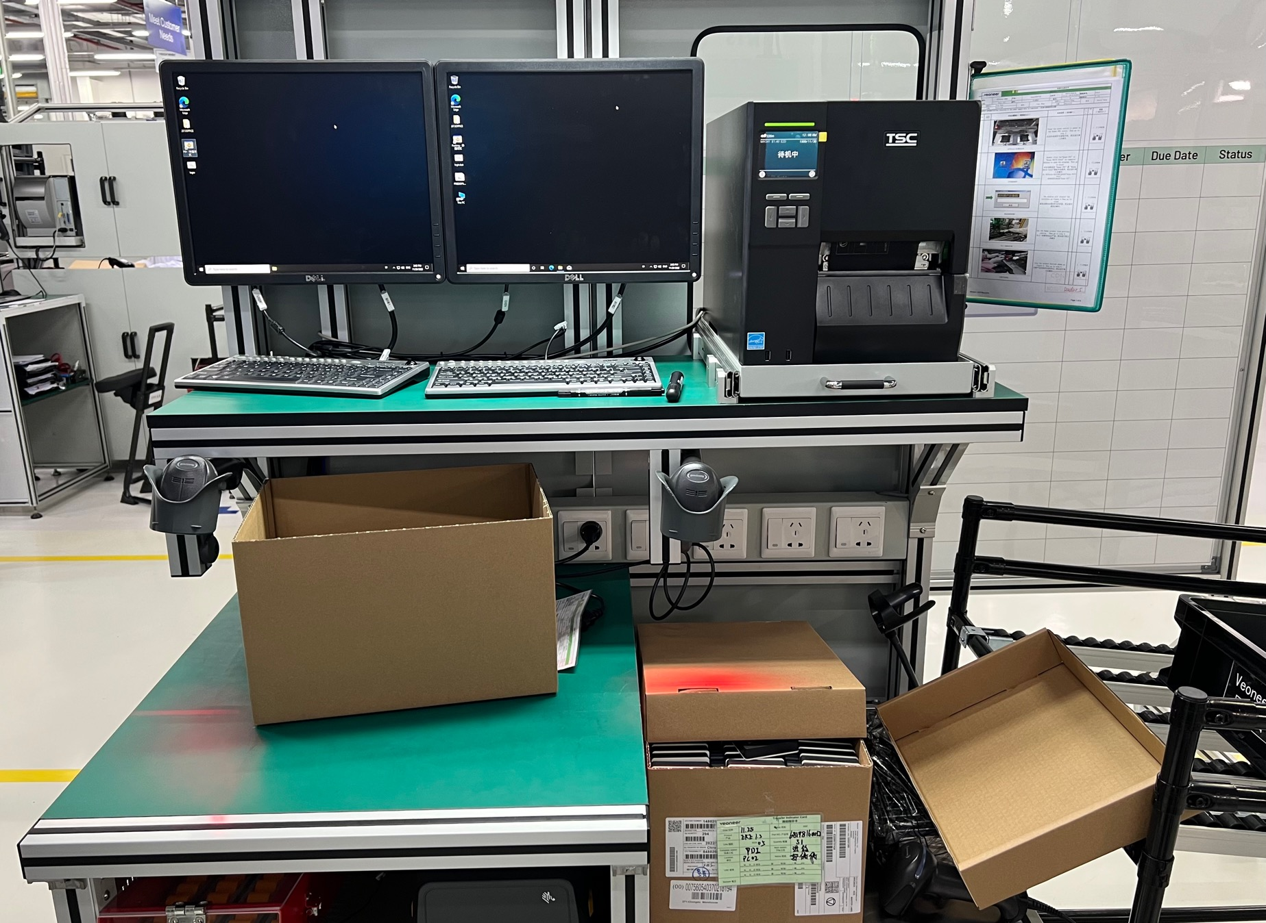
Fig1. VS412+Dispatch Table

Method of measurement
The acceptance criteria has been defined and listed for the Radar5 VS412+Dispatch table and the system will be verified to meet the acceptance criteria.

List of the ACCEPTANCE CRITERIA for vs412+dISPATCH STATION
List of the ACCEPTANCE CRITERIA for Radar-5 VS412+Dispatch table.

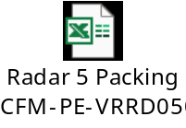

Conclusion
The Radar-5 VS412+Dispatch table is conformed to meet the acceptance criteria and production requirements.

